Spring Semester 2005 Advising Survey
Summary of Results

Conducted, tabulated, and presented by the SSU Student Affairs Committee

October 18, 2005

In Spring 2005 the Student Affairs Committee conducted a survey among almost 1100 undergraduate students about their experiences with and views on academic advising at Sonoma State University. This report summarizes the numerical data collected and points out themes found in the written comments by students.

Overall inferences from the data:

- Of the 1079 students surveyed, 67.8% of the students believe that their advising sessions are effective. 79.3% say that they get accurate information from their advisors. 74.9% say that their advisor is available throughout the semester. These responses indicate that advising at SSU as a whole is not as bad as anecdotal evidence from students suggests. However, it is also clear that advising can be improved. 1/3 of students do not believe that their advising is effective and over 34% of students who receive advising say they need more help with their advising.

- The data from the students strongly suggests that students who meet with their advisor at least once a semester are much more satisfied with the effectiveness of their advising than students who meet with their advisor once a year or less. This suggests that the effectiveness of advising is positively related to the frequency of contact between students and advisors.

Student Affairs Committee Recommendations:

Based on the results of the survey, the Student Affairs Committee makes the following recommendations with respect to the improvement of advising to the Academic Senate and the Associated Students. These recommendations only reflect the committee’s response to the data from the advising survey. These recommendations are not intended to address broader issues with respect to advising on campus.

- Each School should make a strong effort to encourage their students to see an advisor at least at once a semester.
- The Associated Students should also make an effort to strongly encourage students to meet with their academic advisors.
- Schools and departments should investigate and implement structures, procedures, and models that promote frequent advising contacts between faculty and students. The Student Affairs Committee will publish a list of suggested best practices to accomplish this goal.

Advising Survey Background and Methodology

In Fall 2002, the Associated Students passed the “Resolution to Review the Current Advising Policy” in which they requested that the Student Affairs Committee investigate the effectiveness of the current advising policy and make suggestions for revision to improve advising for all students. After looking into the issue, the Student Affairs Committee concluded that the problem does not lie with the Advising Policy but rather with advising practices on campus. The Academic Advising Subcommittee and the Associated Students conducted surveys of Deans, Department Chairs, and students on their views on advising at SSU. The survey of deans and departments was a qualitative study that was concerned with how different departments implemented advising. The survey conducted by the Associated Students collected specific advising stories from students in each school. However, so far no quantitative study of students’ experiences with and satisfaction of advising had been conducted.

In Fall 2004 the Student Affairs Committee drafted a survey to collect quantitative data about advising at SSU. The committee recognized that the quality of advising could be studied at many different levels and designed a brief, one-page survey that only asked very specific questions about undergraduate students’ experiences with advising by their primary major advisor. In Spring 2005, the committee handed out surveys to approximately 1100 undergraduate students. Committee members administered the survey in a variety of classes at different levels (freshman through senior level), and throughout the four schools that serve SSU’s undergraduate population (Science and Technology, Social Sciences, Arts and Humanities, Business and Economics). All undergraduate majors are represented. It was made clear that the surveys were anonymous and that participation was voluntary.

The survey starts with demographic questions: major, gender, class level and if the student is a native or transfer student. The next part of the survey asks how often a student is meeting with his/her advisor and what topics they discuss. Students then are asked if they receive advising from any other sources, such as fellow students, faculty in other departments etc.

The next five questions of the survey ask students to rate how much they agree or disagree with statements that describe their advising experiences:
I have actively sought out advising.
My academic advisor is available throughout the semester (not just during registration).
My academic advisor is willing and able to answer questions about General Education.
The information I receive from my academic advisor is accurate.
Overall, I feel my advising sessions are effective.

Finally, in the last question of the survey students choose one statement that best describes them at the time:
I receive advising and it is helpful.
I receive advising but need more help.
I do not receive advising and I’m doing fine.
I do not receive advising and I need help.

Students also had the opportunity to write additional comments on the back of the survey. A copy of the survey is included as Appendix C to this report.

Whole sample results

Question 4: How often have you met with your primary advisor?
- 60.0 % of students see their advisor once a year or less often.
- 40% of students meet with their advisor at least once a semester.

Question 5: What is discussed during meetings with your primary academic advisor?
- Major coursework is discussed 53.1% of the time.
- General Education requirements are discussed 46.8% of the time.
- Graduation requirements are discussed 33.5 % of the time.

Question 6: Question 6 is a three-part question that addresses where students who are not advised by their department receive advising.
- 37.1% of students receive advising from someone outside the department.
- 23.1% of undeclared students receive advising from outside the Advising Center.

Question 7: I have actively sought out advising.
- 66.5% of students somewhat agree or strongly agree with the statement.
- 33.5% of students somewhat disagree or strongly disagree with the statement.

Question 8: My academic advisor is available throughout the semester.
- 74.9% of students somewhat agree or strongly agree with the statement.
- 25.1% of students somewhat disagree or strongly disagree with the statement.

Question 9: My academic advisor is willing and able to answer questions about GE.
- 76.3% of students somewhat agree or strongly agree with the statement.
- 23.7% of students somewhat disagree or strongly disagree with the statement.

Question 10: The information I receive from my advisor is accurate.
- 79.3% of students somewhat agree or strongly agree with the statement.
- 20.7% of students somewhat disagree or strongly disagree with the statement.

Question 11: Overall, I feel my advising sessions are effective.
- 67.8% of students somewhat agree or strongly agree with the statement.
- 32.2% of students somewhat disagree or strongly disagree with the statement.

Question 12: Indicate ONE statement that best describes you at this time.
- 34.6% of students receive advising but need more help.
- 16.1% of students do not receive advising and need help.

Inferences from the whole sample results

Over 2/3 of the students surveyed believe that their advising sessions are effective, that they get accurate information from their advisors, and that their advisor is available throughout the semester. This indicates that advising at SSU is not as bad as anecdotal evidence from students suggest. However, it is also clear that advising can be improved since 1/3 of students are dissatisfied with their advising and over 34% of students who receive advising say they need more help.

Selected Sub-sample Results:

The following section contains data for selected sub-samples of the results. The data cited below is what the Student Affairs Committee subjectively believes will be of interest to the university as a whole. The entire data set is available to anyone who wants to see it.

Table 1:

Question 11 (Overall I feel my advising sessions are effective) broken down by School.

Major | Sample Size | Mean (1 – 4 Scale) | Standard Deviation
Science and Technology | 247 | 2.91 | 1.002
Social Science | 257 | 2.72* | .989
Arts and Humanities | 213 | 3.06* | .935
Business and Economics | 143 | 2.76* | 1.0
Undeclared | 133 | 2.85 | .963
Total | 860 | 2.86 | .989

Inference: A&H provides students with the most effective advising sessions.
*The mean difference between A&H and SS and the mean difference between A&H and B&E is significant at the 0.05 level. The other mean differences are not statistically significant.

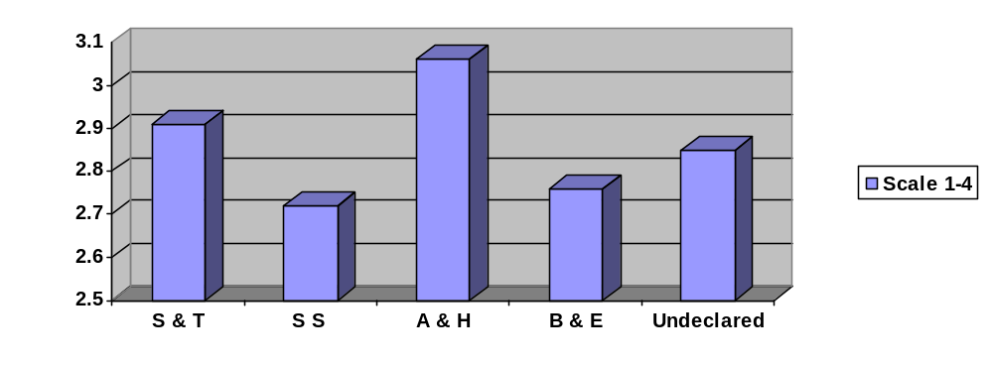

Table 2:

Question 4 (How often do you meet with your advisor) broken down by School.

Major | Sample Size | Mean (1 – 4 Scale) | Standard Deviation
Science and Technology | 265 | 2.77* | 1.397
Social Science | 281 | 2.89 | 1.415
Arts and Humanities | 224 | 3.19* | 1.344
Business and Economics | 154 | 2.69* | 1.286
Undeclared | 144 | 2.95 | 1.561
Total | 924 | 2.89 | 1.382

Inference: A&H students meet more frequently with their advisors than do students from other schools. This may contribute to A&H students feeling that their advising sessions are more effective.
* The mean difference between A&H and S&T and the mean difference between A&H and B&E is significant at the 0.05 level. The other mean differences are not statistically significant.

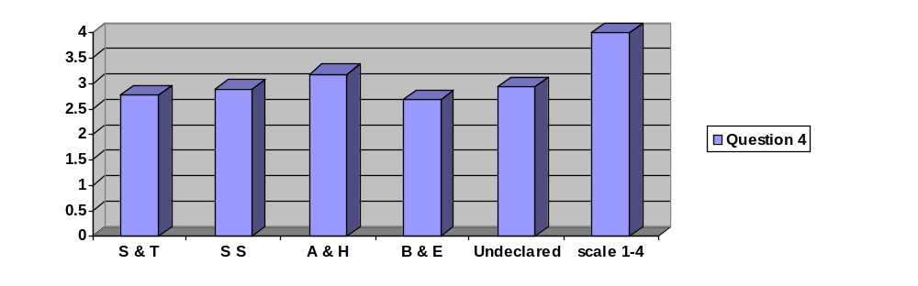
Table 3:

Question 11 (Overall I feel my advising sessions are effective) broken down by class level.

Class Level | Sample Size | Mean (1 – 4 Scale) | Standard Deviation
Freshman | 228 | 2.86 | 1.062
Sophomore | 200 | 2.80 | .977
Junior | 335 | 2.89 | .941
Senior | 233 | 2.87 | .985
Total | 996 | 2.86 | .986

Inference: Effectiveness of advising is consistent across class levels.

Table 4:

Question 4 (How often do you meet with your advisor) broken down by class level.

Class Level | Sample Size | Mean (1 – 4 Scale) | Standard Deviation
Freshman | 246 | 2.73* | 1.635
Sophomore | 225 | 2.60* | 1.323
Junior | 364 | 2.85* | 1.332
Senior | 238 | 3.41* | 1.194
Total | 1073 | 2.89 | 1.406

Inference: As expected, seniors meet with advisors more frequently than other class levels.
* The mean difference between Seniors and the other class levels is significant at the 0.05 level.

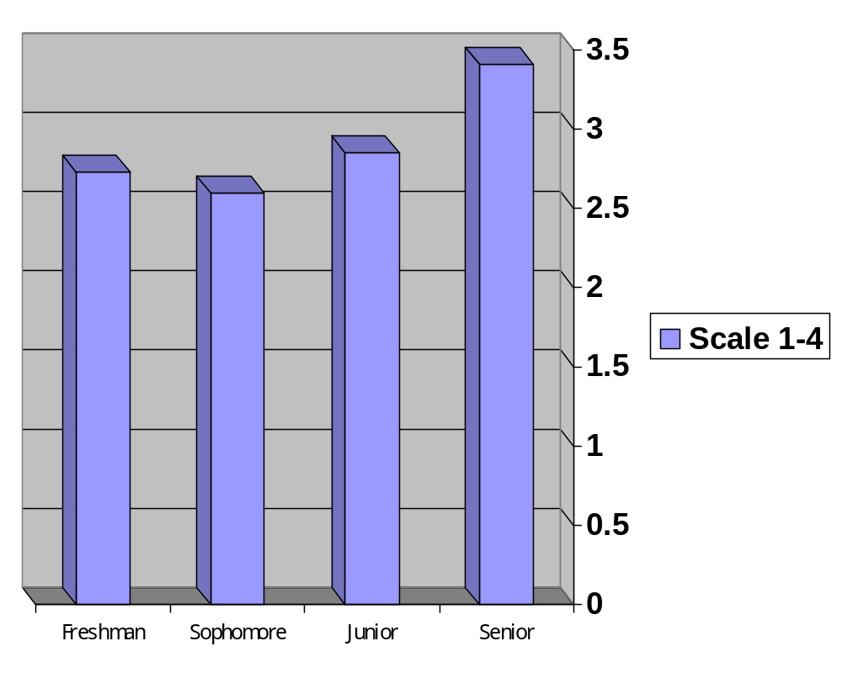

Cross tabulations

Table 5

Question 11 (Overall I feel my advising sessions are effective) cross tabulated with Question 4 (How often do you meet with your advisor) by class level.

How often have you met with your primary advisor
Overall I feel my advising sessions are effective |  | Never | Once | Once a Year | Once a  semester | More than once  a semester
Freshman  Strongly disagree or Somewhat disagree  Strongly agree or Somewhat agree |  | 43  23 | 22  38 | 0  2 | 5  35 | 5  55
Sophomore  Strongly disagree or Somewhat disagree  Strongly agree or Somewhat agree |  | 22  10 | 21  42 | 15  19 | 10  38 | 3  18
Junior  Strongly disagree or Somewhat disagree  Strongly agree or Somewhat agree |  | 21  14 | 32  87 | 12  30 | 20  70 | 10  39
Senior  Strongly disagree or Somewhat disagree  Strongly agree or Somewhat agree |  | 5  3 | 29  21 | 17  36 | 17  50 | 11  42

Inference: Across class levels, students who meet with their advisor at least once a semester are much more satisfied with the effectiveness of their advising than students who meet with their advisor once a year or less.

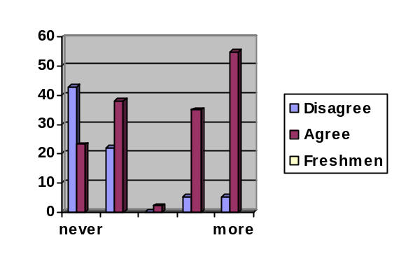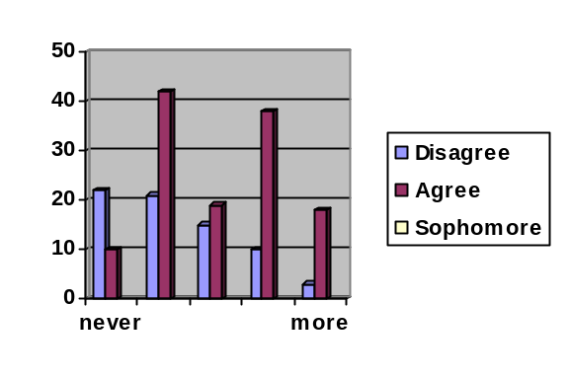
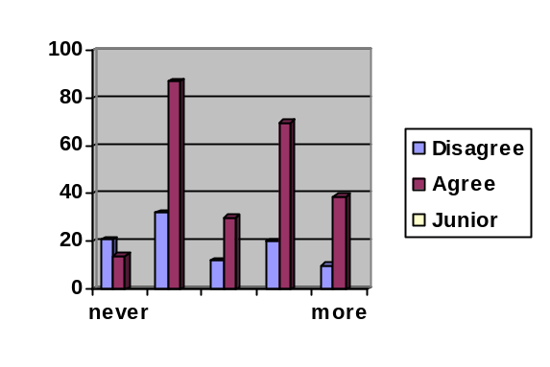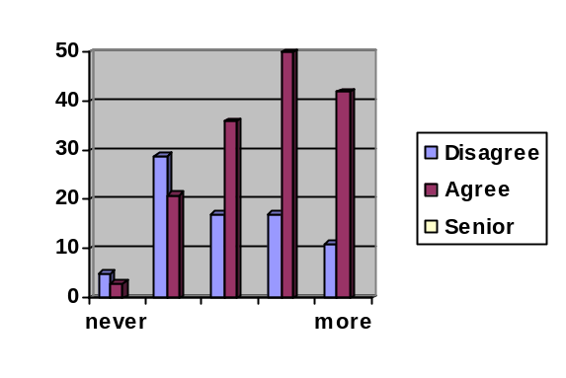
Table 6:

Question 11 (Overall I feel my advising sessions are effective) cross tabulated with Question 4 (How often do you meet with your advisor) by School.
 | How often have you met with your primary advisor
Overall I feel my advising sessions are effective | Never | Once | Once a  Year | Once a  semester | More than once  a semester
Science and Technology  Strongly disagree or Somewhat disagree  Strongly agree or Somewhat agree | 35  14 | 27  55 | 14  18 | 4  47 | 7  35
Social Sciences  Strongly disagree or Somewhat disagree  Strongly agree or Somewhat agree | 25  9 | 30  47 | 11  21 | 21  45 | 8  39
Arts and Humanities  Strongly disagree or Somewhat disagree  Strongly agree or Somewhat agree | 10  8 | 17  34 | 6  27 | 13  50 | 5  40
Business and Economics  Strongly disagree or Somewhat disagree  Strongly agree or Somewhat agree | 18  7 | 16  27 | 9  15 | 8  30 | 3  10
Undeclared  Strongly disagree or Somewhat disagree  Strongly agree or Somewhat agree | 12  12 | 13  25 | 3  5 | 5  21 | 6  31
Inference: As with the class level results, students who meet with their advisor at least once a semester are much more satisfied with the effectiveness of their advising than students who meet with their advisor once a year or less.
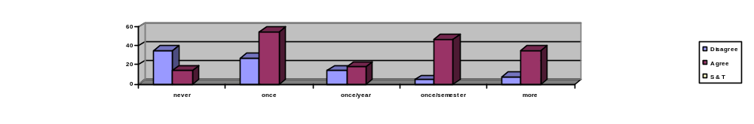
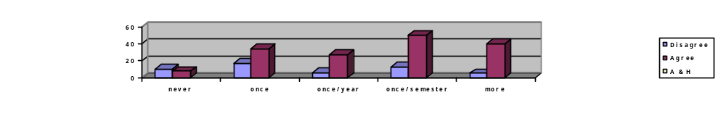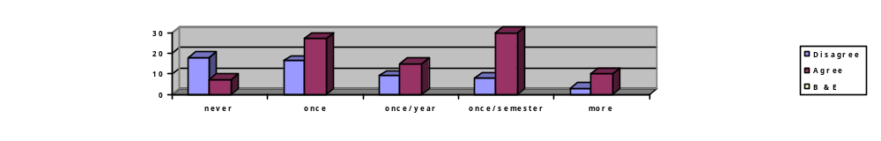
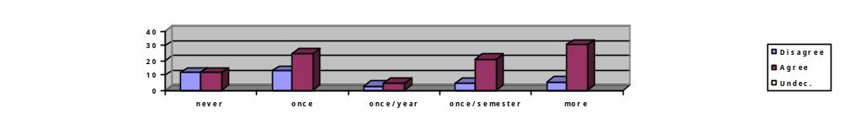
Table 7:

Question 11 (Overall I feel my advising sessions are effective) cross tabulated with Question 8 (My academic advisor is available throughout the semester) by School.
 | Advisor available throughout the semester
Overall I feel my advising sessions are effective | Strongly  Disagree | Some-What  Disagree | Some-What  Agree | Strongly  Agree
Science and Technology  Strongly disagree or Somewhat disagree  Strongly agree or Somewhat agree | 12  3 | 25  9 | 33  67 | 7  90
Social Sciences  Strongly disagree or Somewhat disagree  Strongly agree or Somewhat agree | 15  6 | 23  13 | 33  55 | 11  86
Arts and Humanities  Strongly disagree or Somewhat disagree  Strongly agree or Somewhat agree | 9  4 | 17  16 | 21  52 | 2  90
Business and Economics  Strongly disagree or Somewhat disagree  Strongly agree or Somewhat agree | 10  2 | 27  13 | 12  42 | 4  31
Undeclared  Strongly disagree or Somewhat disagree  Strongly agree or Somewhat agree | 6  1 | 12  7 | 17  44 | 2  41
Inference: Students who strongly agree or somewhat agree that their advisor is available throughout the semester also think that their advising sessions are effective. Students who strongly disagree or somewhat disagree that their advisor is available throughout the semester tend to think that their advising sessions are not effective.
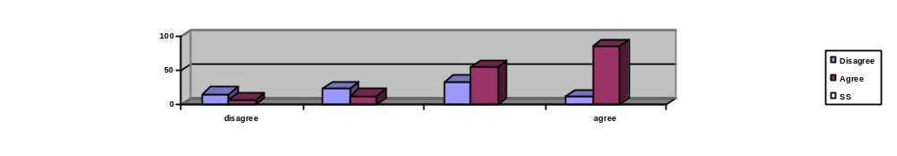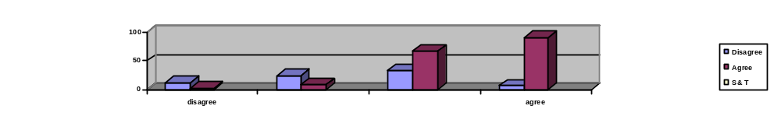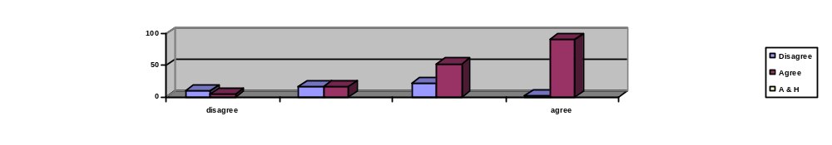
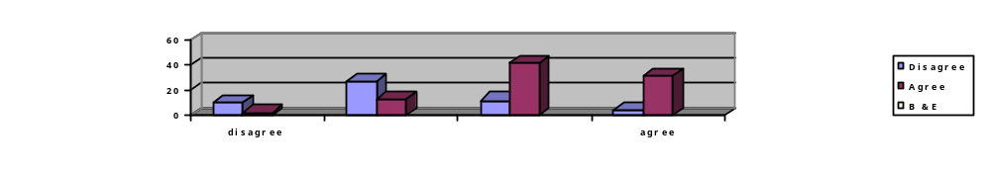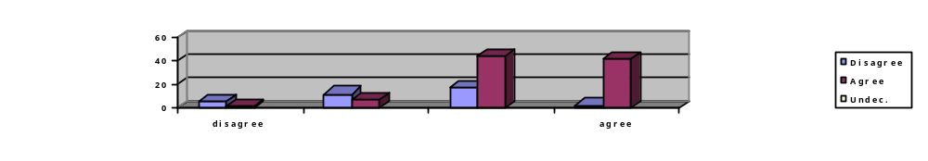

Table 8 and 9
Question 7 (I have actively sought out advising) cross-tabulated with
Question 11 (Overall, I feel my advising sessions are effective.)
 | Overall I feel my advising sessions are effective.
I have actively sought out advising. | Strongly  Disagree | Some-  What  Disagree | Some-What  Agree | Strongly  Agree
Strongly disagree | 33 | 21 | 37 | 6
Somewhat disagree | 24 | 57 | 92 | 27
Somewhat agree | 39 | 74 | 169 | 126
Strongly agree | 25 | 47 | 77 | 142

(Table 9 is just a summary of 8 combining strongly (dis)agree and somewhat (dis)agree.)
 | Overall I feel my advising sessions are effective.
I have actively sought out advising. | Strongly Disagree or somewhat disagree | Somewhat Agree or strongly agree
Strongly disagree | 54 (55.6%) | 43 (44.3%)
Somewhat disagree | 113 (40.5%) | 92 (59.5%)
Somewhat agree | 39 (27.7%) | 195 (72.3%)
Strongly agree | 72 (24.8%) | 219 (75.3%)

Inference: Students who actively seek out advising feel that their advising sessions are more effective than students who do not actively seek out advising. Among the students who actively seek out advising, 75.3% somewhat agree or strongly agree that their advising sessions are effective. Among the students who do not actively seek out advising 44.3% strongly agree or somewhat agree that their advising sessions are effective.

Overall inferences from the selected sub-sample results

Tables 1 and 2 suggest that Arts and Humanities have more effective advising than other Schools on campus. Tables 3 and 4 suggest that the effectiveness of advising is consistent across class levels and that seniors meet with their advisors more frequently than other class levels.

Tables 5 and 6 show that the more frequently students meet with their advisor; the more likely they are to believe that their advising sessions are effective. These results form the basis for the Student Affairs Committee’s recommendation numbers 1 and 2 on page 1 of this report. The idea is simple. The more the university can encourage students to meet with their advisors, the more likely it is that the students will find the advising sessions effective. Therefore, the Student Affairs Committee recommends that individual faculty and departments, and Associated Students strongly encourage students to meet with their advisor at least once a semester. The data in Tables 5 and 6 suggests that this simple action will increase the perceived effectiveness of advising on campus.

Table 7 shows that students who say that their advisor is available throughout the semester are also likely to believe that their advising sessions are effective. These results form the basis for the Student Affairs Committee’s recommendation number 3 on page 1 of this report. As with the frequency data cited in tables 5 and 6, the idea is simple. Just making advisors more available means that students believe that their advising sessions are more effective. Therefore, Schools are encouraged to ensure those faculties are available for advising throughout the semester.

inferences from advising survey written comments

The advising survey also included an open-ended question inviting students’ comments about their advising experiences. About 95 comments were received and several themes emerged that provide insights into why some students are dissatisfied with the advising on this campus. These include:

- Students do not know who their advisors are. In some cases students were not even aware that an advisor had been assigned to them. In others, students actively sought out an advisor but were given incorrect or conflicting information about which department or office within the University was responsible for providing an advisor.

- Advisors are not available to students. A number of students indicated that they had a difficult time scheduling an appointment with their advisor. This seemed especially true for transfer students. Others noted that they would have liked to have met with their advisor more frequently during the academic year but were unable to do so. Some students also said that they felt their advisors took too little time with them when they did meet and came away from their advising sessions without their questions fully answered.

- The information provided by advisors was unhelpful or incorrect. A number of students said that their advisor did not seem to be knowledgeable about graduation requirements or the proper sequence in which to take courses. This was especially true for students with double majors, students earning a second degree and transfer students. Students noted that advisors seemed least knowledgeable about General Education requirements, and in some cases the inaccurate information provided by advisors resulted in the students having to take additional courses in order to meet graduation or major course requirements.

Not all of the comments were negative. A number of students said that they were very satisfied with the advising they received and noted specific departments, faculty or Advising Center staff who were particularly helpful.

Appendix A: Selected Raw Data

How often have you met with your primary advisor?
 |  | Frequency | Percent | Cumulative Percent
Valid | NEVER | 214 | 19.9 | 19.9
 | ONCE | 297 | 27.7 | 47.6
 | ONCE A YEAR | 133 | 12.4 | 60.0
 | ONCE A SEMESTER | 246 | 22.9 | 82.9
 | MORE THAN ONCE A SEMESTER | 184 | 17.1 | 100.0
 | Total | 1074 | 100.0
Missing | System | 5
Total |  | 1079
I HAVE ACTIVELY SOUGHT OUT ADVISING
 |  | Frequency | Percent | Cumulative Percent
Valid | STRONGLY DISAGREE | 136 | 12.7 | 12.7
 | SOMEWHAT DISAGREE | 224 | 20.9 | 33.5
 | SOMEWHAT AGREE | 420 | 39.1 | 72.6
 | STRONGLY AGREE | 294 | 27.4 | 100.0
 | Total | 1074 | 100.0
Missing | System | 5
Total |  | 1079

ADVISOR AVAILABLE THROUGHOUT THE SEMESTER
 |  | Frequency | Percent | Cumulative Percent
Valid | STRONGLY DISAGREE | 71 | 7.0 | 7.0
 | SOMEWHAT DISAGREE | 183 | 18.1 | 25.1
 | SOMEWHAT AGREE | 389 | 38.5 | 63.6
 | STRONGLY AGREE | 368 | 36.4 | 100.0
 | Total | 1011 | 100.0
Missing | System | 68
Total |  | 1079

ADVISOR WILLING AND ABLE TO ANSWER GE QUESTIONS
 |  | Frequency | Percent | Cumulative Percent
Valid | STRONGLY DISAGREE | 81 | 8.1 | 8.1
 | SOMEWHAT DISAGREE | 155 | 15.5 | 23.6
 | SOMEWHAT AGREE | 389 | 38.9 | 62.6
 | STRONGLY AGREE | 374 | 37.4 | 100.0
 | Total | 999 | 100.0
Missing | System | 80
Total |  | 1079

INFO I RECEIVE FROM ADVISOR IS ACCURATE
 |  | Frequency | Percent | Cumulative Percent
Valid | STRONGLY DISAGREE | 61 | 6.1 | 6.1
 | SOMEWHAT DISAGREE | 145 | 14.5 | 20.6
 | SOMEWHAT AGREE | 430 | 43.0 | 63.7
 | STRONGLY AGREE | 363 | 36.3 | 100.0
 | Total | 999 | 100.0
Missing | System | 80
Total |  | 1079

OVERALL I FEEL MY ADVISING SESSIONS ARE EFFECTIVE
 |  | Frequency | Percent | Cumulative Percent
Valid | STRONGLY DISAGREE | 122 | 12.2 | 12.2
 | SOMEWHAT DISAGREE | 199 | 20.0 | 32.2
 | SOMEWHAT AGREE | 375 | 37.6 | 69.8
 | STRONGLY AGREE | 301 | 30.2 | 100.0
 | Total | 997 | 100.0
Missing | System | 82
Total |  | 1079

ONE STATEMENT THAT BEST DESCRIBES YOU AT THIS TIME
 |  | Frequency | Percent | Cumulative Percent
Valid | RECEIVED ADVISING AND HELPFUL | 329 | 30.9 | 30.9
 | RECEIVED ADVISING BUT NEED MORE HELP | 369 | 34.6 | 65.5
 | DO NOT RECEIVE ADVISING AND DOING FINE | 196 | 18.4 | 83.9
 | DO NOT RECEIVE ADVISING AND NEED HELP | 172 | 16.1 | 100.0
 | Total | 1066 | 100.0
Missing | System | 13
Total |  | 1079

SCHOOL
 |  | Frequency | Percent | Cumulative Percent
Valid | S&T | 266 | 28.6 | 28.6
 | SS | 282 | 30.4 | 59.0
 | A&H | 227 | 24.4 | 83.4
 | B&E | 154 | 16.6 | 100.0
 | Total | 929 | 100.0
Missing | System | 150
Total |  | 1079

Descriptive
OVERALL I FEEL MY ADVISING SESSIONS ARE EFFECTIVE BY SCHOOL
 | N | Mean | Std. Deviation | Std. Error | 95% Confidence Interval for Mean
 |  |  |  |  | Lower Bound | Upper Bound
S&T | 247 | 2.91 | 1.002 | .064 | 2.78 | 3.03
SS | 257 | 2.72 | .989 | .062 | 2.59 | 2.84
A&H | 213 | 3.06 | .935 | .064 | 2.93 | 3.18
B&E | 143 | 2.76 | 1.000 | .084 | 2.60 | 2.93
Total | 860 | 2.86 | .989 | .034 | 2.80 | 2.93

Appendix B: Written Comments

* indicates a deleted name

* - Excellent professor and advisor

I’ve been unable to find out who my advisor is, no one has given me a straight answer in 4 years.
I felt the advisor in the advising office that I saw was not helpful at all.

I dropped out last week.
My advisor retired.
There needs to be an advisor for the school that can answer questions about double-majoring and getting a 2nd BA or BS.
Need counselors for double majors and getting a 2nd BA or BS.
I’ve tried to look up my advisor, but I apparently don’t have one. I think if I was assigned one right from the start, I’d be in a better position now.
I do not have a primary advisor. It would be easier if advisors were available in the evening. When I received advising, I was misguided regarding the graduation requirements.
I would not have received any help had I not actively sought it out. I had to call and find an advisor when I transferred here.
Help freshman find advisors.
I have a double major with Spanish and Cals but I have the same advisor for both majors.
Everyone is too busy to help.
Hutchins has always been available for advising even if the professor is not your advisor.
Found it terrible difficult to figure out who was my assigned advisor.
I do not use advising, but I know that if I have questions there is someone who can and will help me.
When talking with me, gave answers so fast and did not always take the time to make sure I understood. I would have liked a little more time spent.
I think there needs to be more advising during the first two years because this is when I felt most lost and unsure of the classers I was taking. The freshmen seminar didn’t help with my coursework.
I was never assigned a specific advisor and to this day am not sure who mine is, I had to find my own help.
There should be mandatory student advising sessions to keep students on track.
Perhaps some students need to be assigned to advisors because we don’t know who to go into within the department or major.
There needs to be a better way to keep track of GE and graduation requirements.
I don’t even know who my advisor is. I just entered the psychology program before that I didn’t receive advising either.
I do not have an academic advisor although I have filled out a form requesting one at orientation.
I am not receiving regular advising because of my lack of willingness to do so. It has nothing to do with the availability or unavailability of staff.
I met with my advisor and it seemed to me as though the questions I asked he couldn’t answer three times he had to get up and go ask another advisor for the answer. He also knew nothing of GE’s stuff.
The only ti8me
I have sought advising is during the transfer student orientation back in Dec. How ever I found out that personal advising was not available at that time, and haven’t sought advising since then. Although I intend to soon.
I have not yet attempted to search out my advisor, but it is my intention to do so soon. The advising I received at orientation was enough to get me started on this semester and to have a general idea what I need overall.
Major advisors don’t know GE requirements as well as they need to. We need access to advisors who will help with GE and to our major advisors.
When I was undeclared, I had an awful time with advising. The advising center always gave me the run around and never put me in the right direction.
When I transferred in I was unable to meet with an advisor before registering. I found this unusual and frustrating because I was considering a minor or double major, so choosing the correct classes for a long term goal felt critical.
Freshman seminar instructor gave inaccurate information which caused me to take unneeded classes and put me behind.
The mathematics department lacks a truly cohesive advising system.
Create career advisors like the Community College System. System. The people usually have master degree and know what they talking about. Professional Career counselor would save a lot more money in the time students spend attending SSU and loss of income from prolonged stay at SSU.
Life is good when you have the same advisor every semester. Life is bad if that advisor sucks.
I think it is ridiculous that as a Comms major I am not allowed advising until my sophomore year now I need help now.
My academic advisor was knowledgeable for the most part, but unwilling to go over all of the GE requirements. He pretty much told me to figure it out myself.
I have never met with my assigned advisor because I never knew who it was. I instead made my own contacts and picked my own advisor.
I didn’t know I had a primary advisor or exactly what he/she can do for me.
I felt my advisor was biased toward gaining a student for their department, rather that dete4rmining what would be in my best interest. A mistake on their part has already set me back a year and a half.
Even though I declared a major, I was never assigned an academic advisor, nor was I ever told how to obtain one. I believe that academic advising should be mandatory for all students and should be completed at least once a year.
It needs to be made clear to students who their advisor is. I had to go to the business department to find out for myself.
My advisor * left after my 1st semester so I no advisor and apt. help from * or * who are wonderful.
Where ever I go to advising, I only see *. I have attempted to receive advising from other staff, and I have gained very little from those experiences.
Once I declared my major, there has been less advising appointments. I got more help from * freshman seminar.
I have met with my advising advisor but she is not in the major that I am majoring. She is an EOP advisor and I am a Pre-Health major who should I talk to?
My advisor knows a lot about what Chem. Classes I should take, but does not know anything about the rest of the school, I asked him about EPT records and he did not know where to send me.
All of my advising counselors for undeclared are great. They are always available and willing to help. * and * have not only helped me substantial but inspired me to achieve academic greatness.
For pre-nursing majors, such as myself, it would be beneficial if they had a special advisor that was from the nursing dept. instead of having to meet with the undeclared advisors who know very little about the nursing requirements.
I have been here 4 semesters and only received advising twice we should be assigned advisors.
I am very happy with my pre- business advisor. She has been extremely helpful and she helps me decide on classes to take with in my major as well as GE classes.
In the Hutchins school of liberal studies, the professor from our Libs. 302 class is supposed to be our primary advisor. She was unavailable and unhelpful so I have sought advice of those in the office.
I did not meet with my assigned advisor, but did seek out advising through the main office. It seems like there is a big difference you receive, depending on whom is advising you.
Advisors do seem to need more information on classes and information that dose not only have to do with the major. They have been helpful with finding out things they do not know, but not in a very timely manner.
I have had several advisors through out my 3 semesters here, Out of all 6 of them only 2 have been helpful. The others made me feel as if they were expecting me to know GE requirements. I had a difficult time knowing what I needed to Graduate.
Being a transfer student I have found it very difficult to get the advising that I need. I am running around in circles because I can’t find the accurate information that I need. I did receive help from the Dean of Social Science, but other than that help has been minimal. I am transferring again to another 4 year college.
The advising on this campus is not very organized. I have seen my advisor who does not help me. I feel like I have to figure everything out on my own. They are unable to answer my questions and don’t know about important resources.
I have received conflicting advice before I stuck with one professor for advising. He, although, was not too well versed on the upper level GE I needed to graduate, my Anthro. professor was and that helped.
It should be easier for students to get advice from teachers and advisors who actually want to help and find a way to help the student. Career advising is important just as much as educational choices.
In my 8 years at SSU, I have never been misadvised. I personally think students don’t pay attention to their advisors or they don’t know what questions to ask.
* is doing as well as she can, but the university needs to make more concrete decisions about what they want from the HD majors.
I understand the department is under staffed but it still needs to be more helpful to us students, because everywhere on campus is under staffed but other students are being advised with good material something needs to be done immediately that is effective. Students should not continue to suffer because of the budget cuts.
It always feels as if the advisors do not have enough time for all of the students. I waited 3 hours to get less than 5 min. of his attention. There should be more advisors in the Sociology department.
I feel as if academic advising is available but also feel it is somewhat difficult to figure weather or not I am taking the right classes in order to graduate on time. I feel as if there needs to be more talk and help available to figure out what GE’s I should take I don’t necessarily believe the school is helping students try to graduate in 4 years and is pushing 5 instead.
I think the advisors need to be more available to help answer questions, transferring is something in my future and I feel as I am getting no help with the process.
I have thought about getting advising but I am not quit sure how to go about doing it I know I could more actively try but I have not and if I did know how I would most likely ask for advising.
Even though I came in with a declared major, I would have liked to talk with an advisor just about GE info, outside of my major. Just for general questions.
I do not feel that enough advising is organized in Hutchins. I have heard that other majors have required meetings with their advisors and I feel that would be beneficial on a yearly basis.
Advising for pre-business majors is very helpful but difficult to get during registration time because there is only one advisor for a very large number of students, more available advisors would be great.
When I was an English major I sought advising and they gave me advice that was not accurate and I ended up taking a bunch of classes that I did not already fulfilled the requirement and no one told me for Journalism I needed to be in Coms.
At the time of advising I felt like my advisor could have had my transcript information in front of her I feel like I’m taking lower level classes that might have been covered before. I feel like yearly advising should be mandatory and that my advisor should be familiar with my accomplishments and intentions.
I went to 2 different English advisors. The first was unsatisfactory, but * made up for it. She spent an hour plotting out the courses I needed. I will always seek her advice.
I have never actually been advised by my assigned advisor. The advisor I see in undeclared was better than any in my department. I have seen a couple professors in my department, some act as if they don’t have the time, others sit down and explain and answer my questions.
Sociology Dept. doesn’t give you a specific advisor. * has been the only one that could help me newer teachers couldn’t help me as I was a transfer student and my records confused them.
I went to an advisor to switch my major to kinesiology. When he advised me he told me that I would never be admitted into any graduate school, so I should choose a different concentration. After that I never went back and just followed the catalog.
I just declared Spanish as a major and am applying to apply to Spain and graduate immediately upon returning. I have gotten different messages from my advisor than A and R.
I have gone to the EOP advising and it confuses me in regards to my major advisor about GE. I suggest these advisors from EOP have more contact with other departments’ major advisors so they can be more effective.
My issue has less to do with advising than it does with Admissions and Records. Twice now I’ve “enrolled” in a class, only to find out well after the fact that I could not enroll because of unit requirements. I found out online but was never called and informed that there was a problem. But my advisor is great.
Advisors within the department are unable to have office hours as often because they teach several courses. It would be helpful if students who have already graduated with a major from that department could be available to speak to students when professors are too busy to do so.
As long as I follow my course catalog, what does it matter if I have an advisor or not. With higher tuition rates, I have to work more than before, so who has time. Plus, with a ridiculous amount of reading in B.S. GE course this semester, I hardly have time for myself.
My advisor in my major department is great, but when I was undeclared and sought help from the advisors in Salazar I was very frustrated. They were disorganized and only reiterated what I already knew or could read for myself. I feel like I knew more than they did I left feeling frustrated and with a lack of confidence in the system I have to comply to.
I feel that SSU generally, is very disorganized. I feel like every time I go one place or to one person, I am sent somewhere else for an answer. Advisors are not informed well enough on due dates, requirements and so on. I also am about to change advisors simply for the reason that I need someone more approachable, accessible and willing to find out things for me that she may not know.
I have recently changed my advisor in the ACMS department because I didn’t feel that * was advising me properly. It was too vague and I feel that she really didn’t know what or care what she was doing. She is a good professor, but as an advisor I was not happy. I have recently changed to * and he has gone out of his way to help me out. I feel that he actually cares that I graduate. I plan to graduate next semester and if * is right in advising I should.
The advisor I was originally assigned, *, became very disinterested in helping me when I decided to change my career choice from medical school. He was completely unhelpful with GE requirement questions he said see box chart and figure out for yourself. Then was ‘too busy’ to talk to me. So I switched to * and he has made himself available, always takes time if he’s in his office to discuss my needs and goals even if I drop in to ask questions and has been really helpful and nice. .
My advisors do the best they can with specifics to my major. There is not a lot of support with GE just because that is not their area of knowledge. I am a Sr. at SSU and still feel as though I have no idea how the system works or how to go about being an active participant in the bureaucracy governing my education I have only been prepared for the goal of graduation and nothing else.
I feel that many advisors are not well informed about GE requirements nor major requirements. Major requirements change from year to year and advisors need to be well informed of changes. I have gone many times to see different advisors because the department had not assigned me an advisor until my second semester. I was coming in as a junior and I did not have time to waste going from advisor to advisor get half- ass and different info. each time.
As a transfer student, I have had a lot of difficulty receiving help and I have got the run around from several individuals. One person I met with from the Psych department * didn’t know barely anything about my GE questions. I have even met with the dean of Psych and I have often left feeling more confused, needed additional help, and felt rushed throughout all of my meetings with him. I have had difficulty attaining classes as well. As a transfer student I am very frustrated with the help I have received at Sonoma State.
I have heard from numerous students on campus that have seeked advising are told something different every time. One in particular was told for the past 3 semesters they were still a sophomore then another advisor said they could graduate in 2 semesters. I was told I was told I won’t graduate for another year by one advisor then another said this spring. Everyone needs to get on the same page. I have not had a great advising experience at all, along with quite a few of my peers.
My advisor did not know anything about GE requirements, and that is what I needed help with the most. He also could not clearly explain which major classes I needed to take in order to graduate in 4 years. The only information he could offer me was about specific classes that he taught, but I would have read about that in my course catalog. I found him to be very unhelpful.
The academic advising center for undeclared students is great. But when I was undeclared I was seeing to many different advisors that I often found myself taking the wrong classes or classes that were unnecessary at the time. I found that if I stuck with one advisor my classes and my goals were achieved easier. * is a great advisor and now that I am an English major I found it difficult to seek out another advisor. For generic issues I still go see *, he’s more helpful.
Freshmen year when I was deciding on a major I went to about 3 or 4 different undeclared advisors each giving me different information and different advice. Eventually, I went strait to different departments who sent me to many other advisors. It was very frustrating to not have one advisor who could answer my questions. Eventually I just found a Professor I liked and asked her about the rest of my questions. Someone once told me everyone is given an advisor, however to me and many others I’ve talked to this is just a myth.
I am required by the athletic department as an athletic to obtain early advising each semester in order to plan out and schedule, turn it in, and be eligible for priority registration. Last semester was the only time I encountered any problems. I was entering the spring 05 semester at the edge of upper classman standing with 59 units, still technically a sophomore. Most of the courses I was advised to enroll in were upper division, which I was told I would receive upper division credit for. But by the time classes started I was told by some of my professors that I might not admit or that I would be thrown out. Two professors threatened this, one followed through. She actually kicked me out of class to make room for a senior even though once the units transferred, I would be just as entitled to be there as she. I was just wondering since other professors told me I shouldn’t necessarily be in these classes if it was an advising issue or if that power is at the professor’s discretion. I barely made it out of the semester with 12 units, hardly a worthy work load for someone wanting to graduate in 4 years, and barely enough to stay eligible for the next season. When I spoke to my advisor about it she said “Oh I thought you had 60 units.” So needless to say I was freaked out.
I am graduating and have had many problems with Advisers and Admission and Records not giving me the right advice. Admission and Records have sent grad papers to wrong address, have told me my papers weren’t ready when they were 4 months ago. Have said I hadn’t taken a class when I have. Also my advisor counted the wrong number on my transcript and told me I had another semester, but when I saw him again he gave me the right number I had on my transcript and told me I could graduate, after he had told me I couldn’t, thus I had to rush to graduate. If I was given the right advising and admission and records front desk knew what they were talking about, when students ask. It would save me a lot less stress. I pay a lot of money to go here.
The professors in Political Science are not helpful in advising any kind of tailored class schedule to help me regarding law school. In fact it is widely accepted that the department is against law school altogether and I have been referred to other professors in other departments to seek advising for law school. How am I supposed to choose an advisor from a department that I have never taken any classes from? How come Political Science is a common major for those hoping to go to law school but every professor is against it? I feel that when I ask a professor for advising I am bothering them from their main concern which is teaching their discipline.
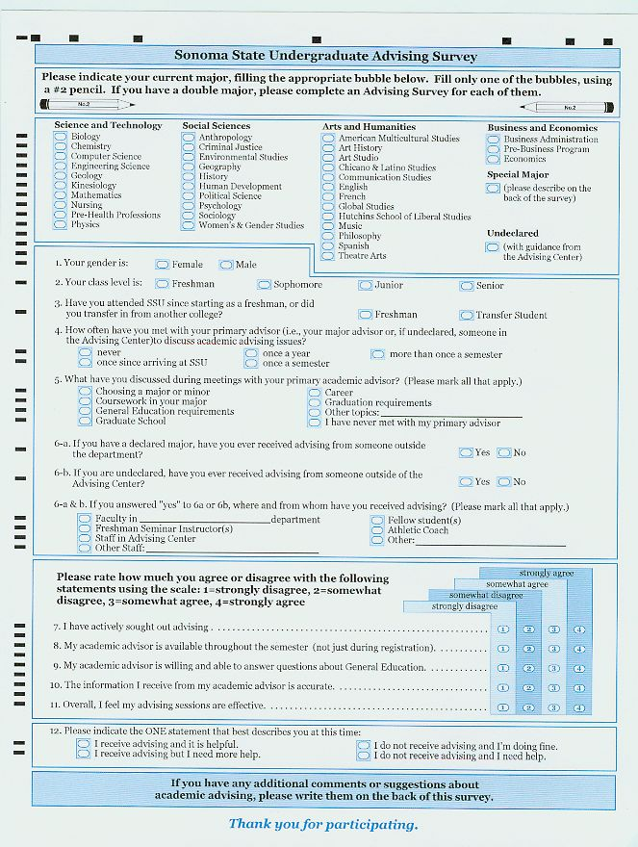
Appendix C: Sonoma State Undergraduate Advising Survey

